PROPOSED EXCURSIONS:

Thursday afternoon:

Paphos: ‘A world cultural Heritage site’

- Half Day Excursion

Visits to:
- St. Paul’s Pillar
- City Tour
- Paphos Mosaics
- Paphos Old Harbour “Limanaki” (free time)

First visit of the day will be that of Saint Paul's Pillar. Saint Paul visited Pafos in 45 AD in an attempt to convert the ruler of the time to Christianity. He was successful in his efforts, but not before being tied and whipped to this otherwise unremarkable lump of stone. The pillar is one of several popular stops for pilgrims who come to see the religious sites of this early bastion of the Christian faith. He received 40 lashes for Evangelising on the island.

Paphos founded in 4th century B.C. by the last king of the city kingdom of Palaepaphos thanks to its natural harbour. It soon became the capital of Cyprus during the Hellenistic and Roman periods and is featured on the World Cultural Heritage List of UNESCO since 1980. A city tour by coach will give everyone a general view of the town.

Next visit the picturesque harbour where the residences of the Roman capital are located including that of the Roman Proconsu l with their outstanding floor mosaics recounting the stories from Greek Mythology: The House of Dionysos, Aion, Orpheus and the Villa of Theseus.

Some free time will be given to the participants at the picturesque harbour for a stroll and souvenir shopping!

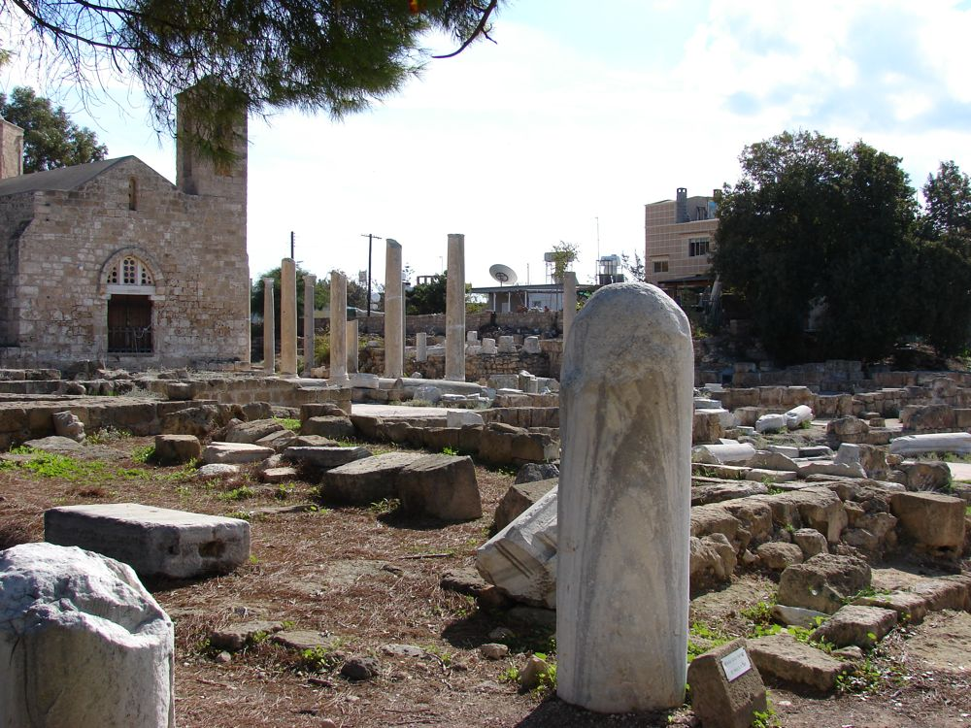

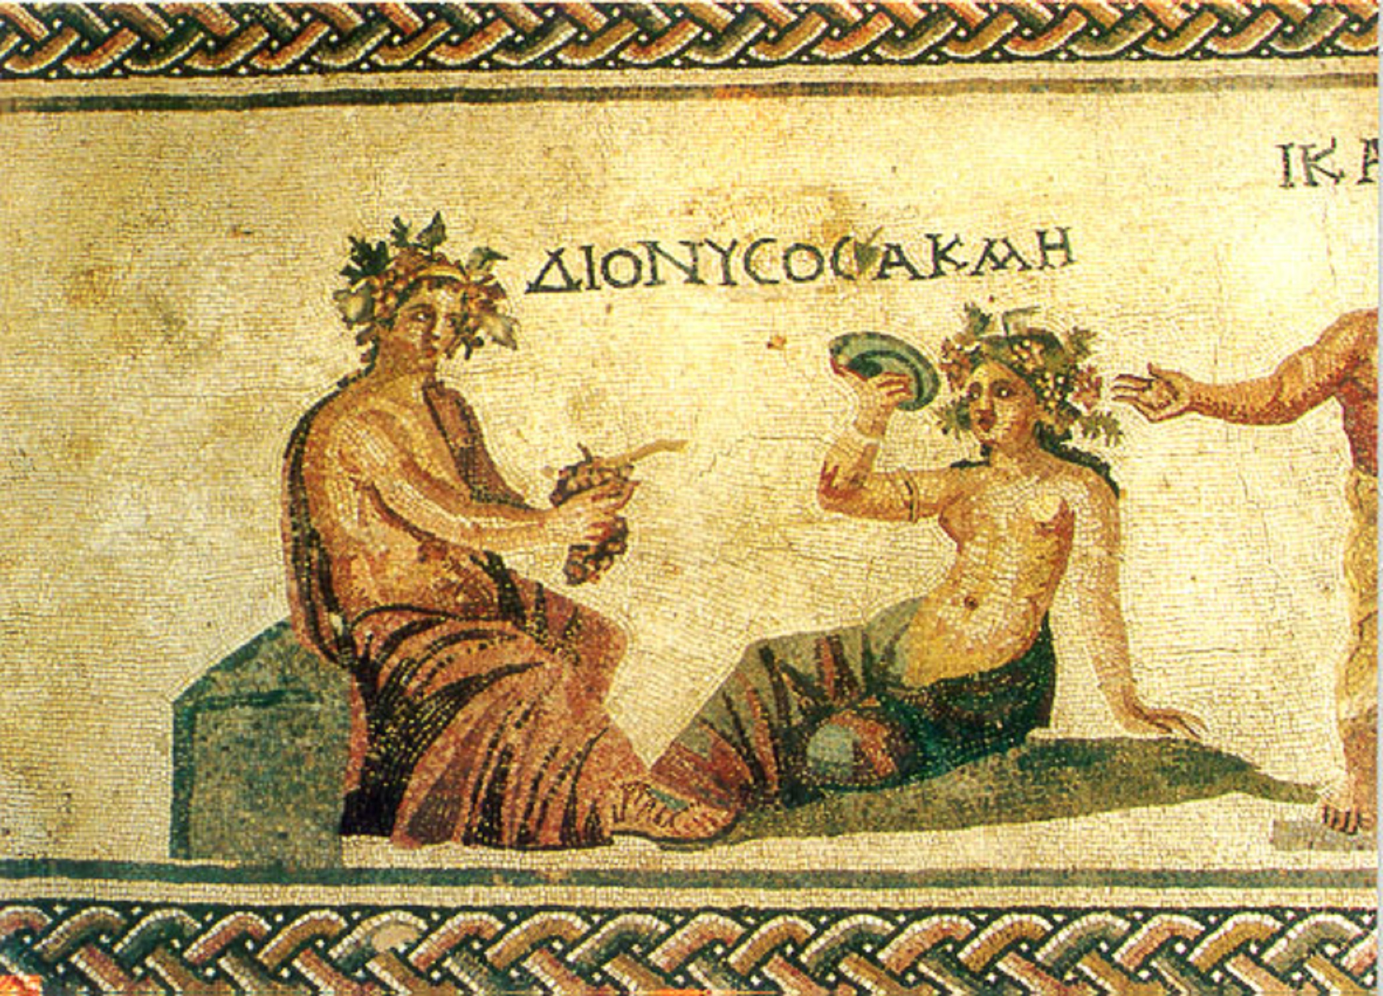

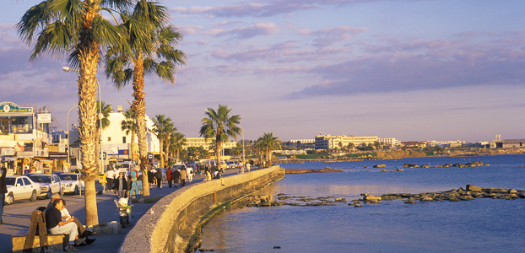

PRICE: €25,00 per person

The following services are included in the above price:
- Private coach transfers
- Licensed English speaking Guide
- All relevant entrance fees for archaeological sites
- Organisation and assistance by Smart Events

MINIMUM NUMBER OF PARTICIPATION 15 PERSONS

Friday Morning:

KOURION-KOLOSSI-LIMASSOL

- Half Day Excursion
- Visits to:
- Aphrodite’s Rock (Petra tou Romiou)
- Kourion Theatre
- Limassol Old Town
- Limassol Marina

The journey will then follow the breath-taking coastline of “Petra tou Romiou”, the legendary birthplace of the goddess of fertility, Aphrodite. A stop here is without any doubt a must. This has been regarded as the gateway to Paphos for centuries!

A beautiful boulevard of Cypress trees and citrus plantations will guide the participants to the former city kingdom of Kourion founded in 12th century BC. Here they will visit the Greco-Roman theatre with its breath-taking coastal view and the early Christian mosaics in the House of Eustolios and the Kourion Basilica.

The guest will then have free time to walk through the pedestrian area of the old town of Limassol, with the guide whereby the guests will have the opportunity to get a taste of the town.

Next visiting point will be the Limassol Marina; an exclusive waterfront area which has been designed and developed by a world-renowned team of architects and engineers. It combines elegant residences and a full service marina with exclusive restaurants and shops, to create a lifestyle uniquely shaped by ‘living on the sea’.

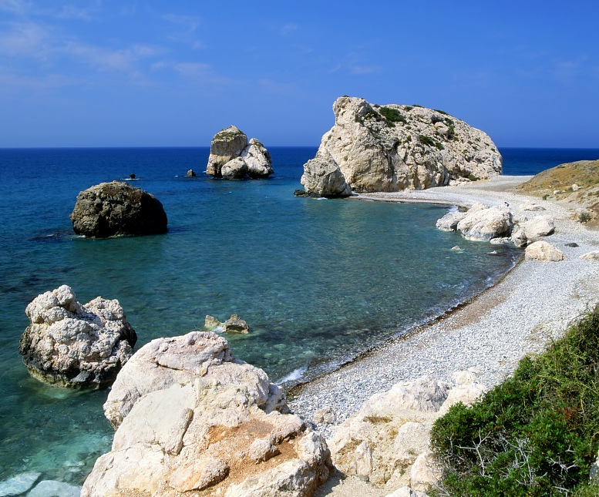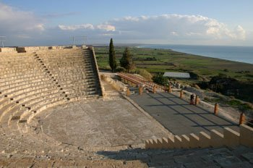

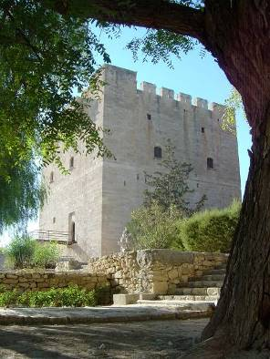

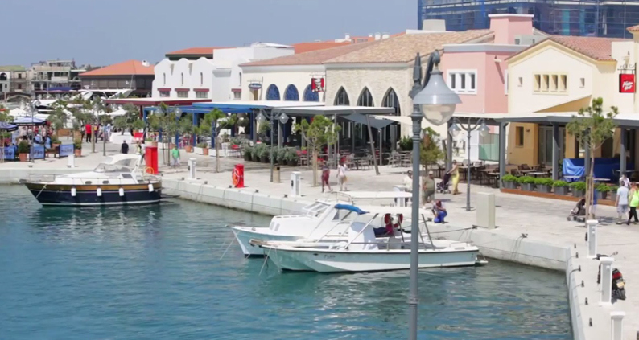

PRICE: €30,00 per person

The following services are included in the above price:
- Private coach transfers
- Licensed English speaking Guide
- All relevant entrance fees for archaeological sites
- Organisation and assistance by Smart Events

MINIMUM NUMBER OF PARTICIPATION 15 PERSONS

